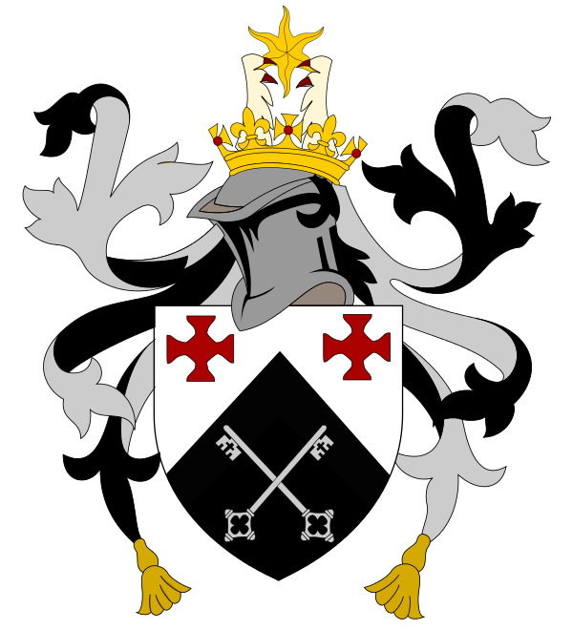

St Aidan’s College Alumni Association

Annual General Meeting

To be held on Saturday 16th November 2019

Time: 2pm

The Shincliffe Room, St Aidan’s College

- Introduction and welcome
- Election of Chair for AGM
- Apologies for absence
- Minutes of the 2018 AGM
- Committee members reports:
  - Treasurer
  - Newsletter
  - Archive
  - Reunions
  - Digital Communication Officer
  - Careers Development Officer
  - Secretary
- Election of officers
- Review of Association aims set at 2018 AGM (see 2018 minutes)
- Any other business

